5-Pepper Pepperoni, Salami, Ham, Bacon and Chorizo. Optional BBQ, Sweet Chilli, Smokey BBQ, Tomato... Made with 100% free range ingredients.

Pepperoni

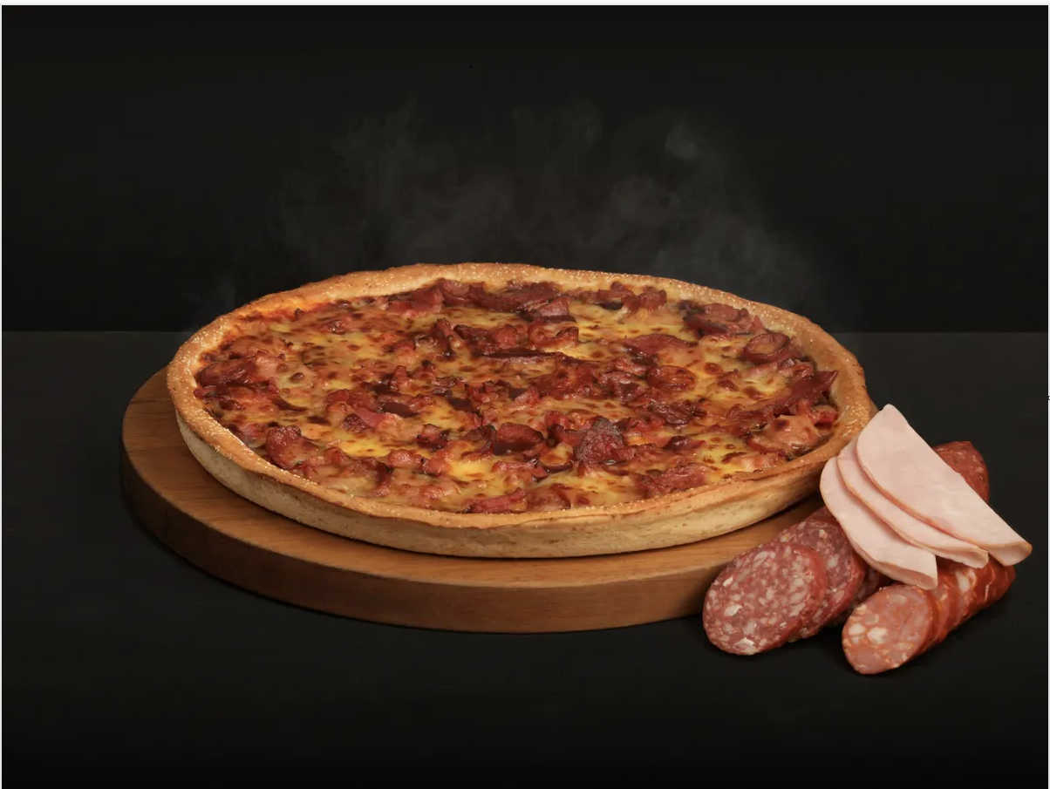

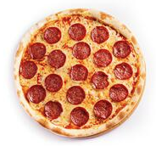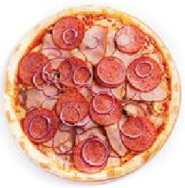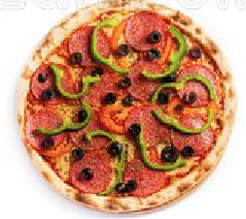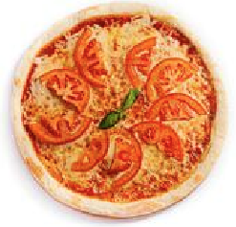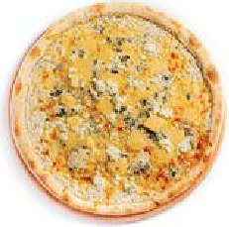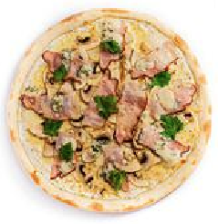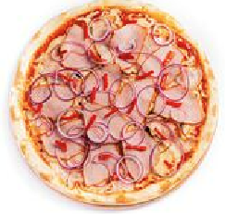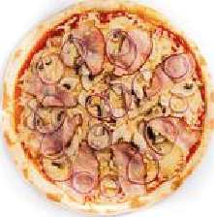

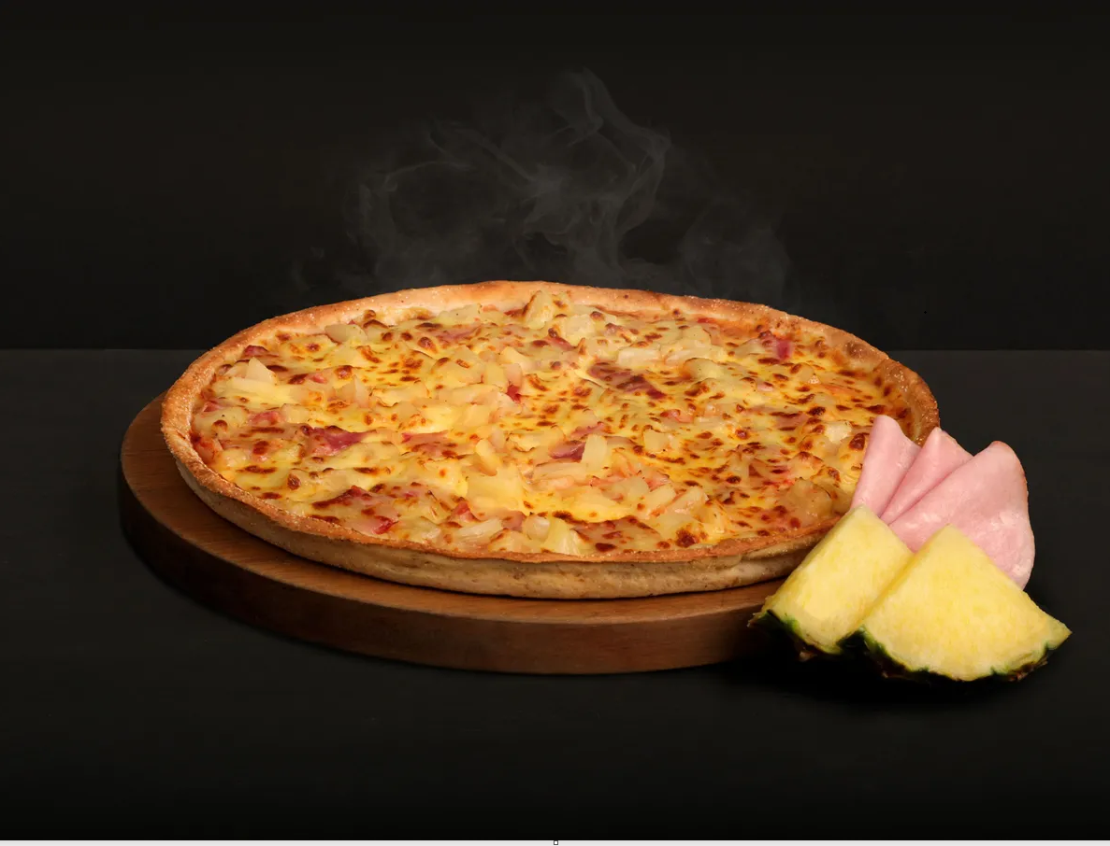

Prosciutto

Double Ham, Double Pineapple and Double Cheese. Made with 100% free range ingredients.

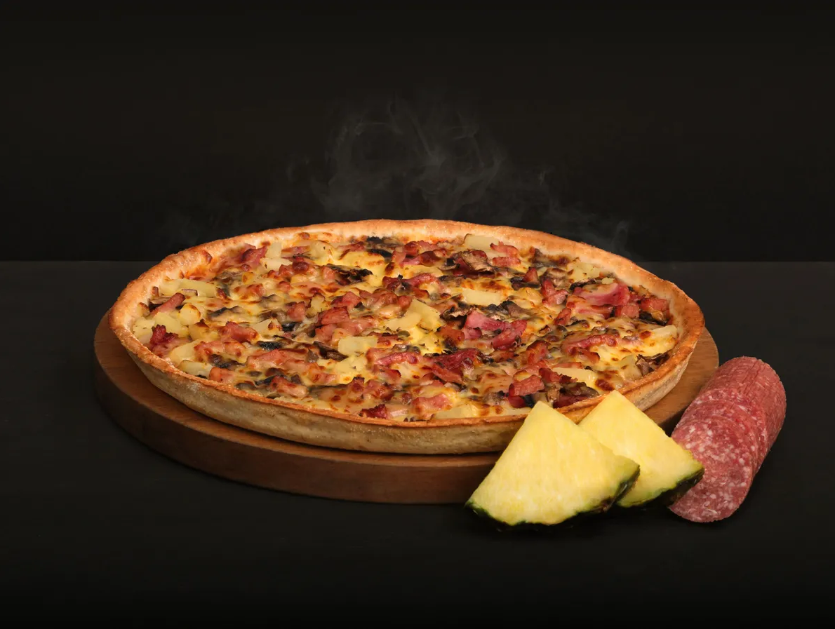

Alla Capricciosa

Salami, Ham, Onions, Mushrooms, Pineapple and Bacon. Made with 100% free range ingredients.

Wrath

5-Pepper Pepperoni, Onion, Capsicum, Tomatoes, Chilli. Optional Kalamata Olives, Jalapeno Peppers and Anchovies. Made with 100% free range ingredients.

Napoletana

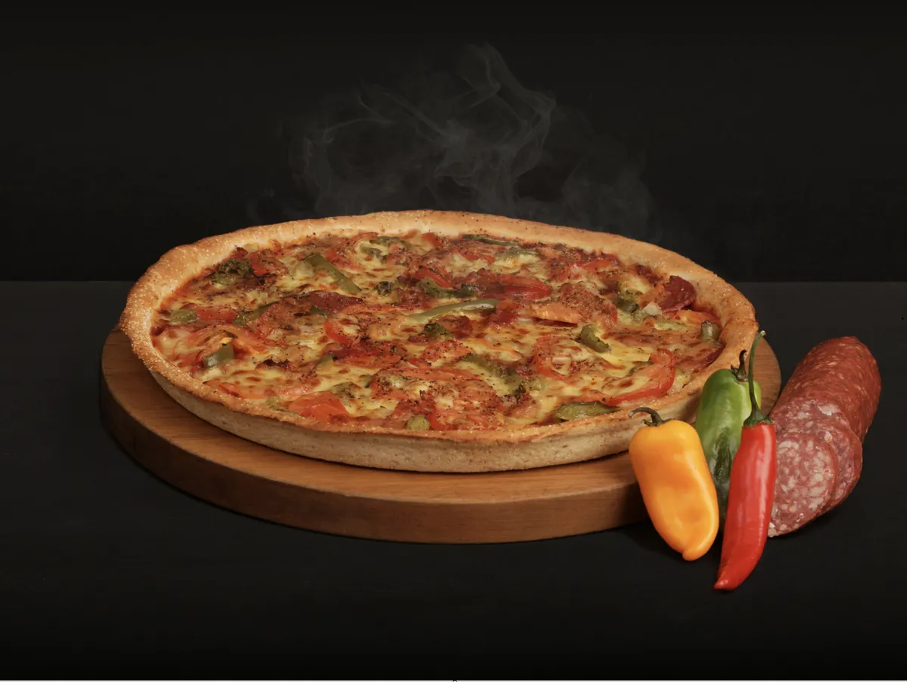

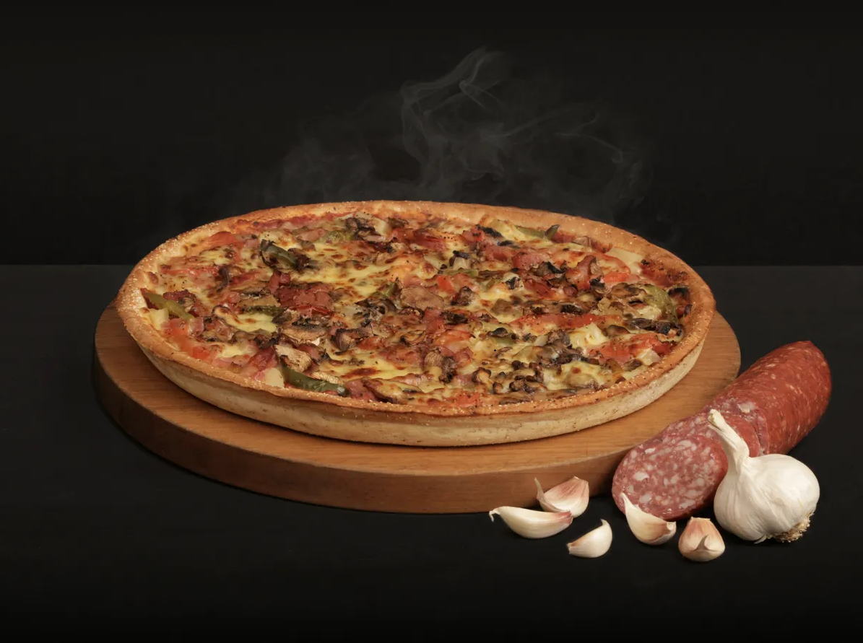

Gluttony

Onion, Garlic, Salami, Ham, Mushroom, Pineapple, Capsicum, Tomato, Bacon, Black Pepper. Made with 100% free range ingredients.

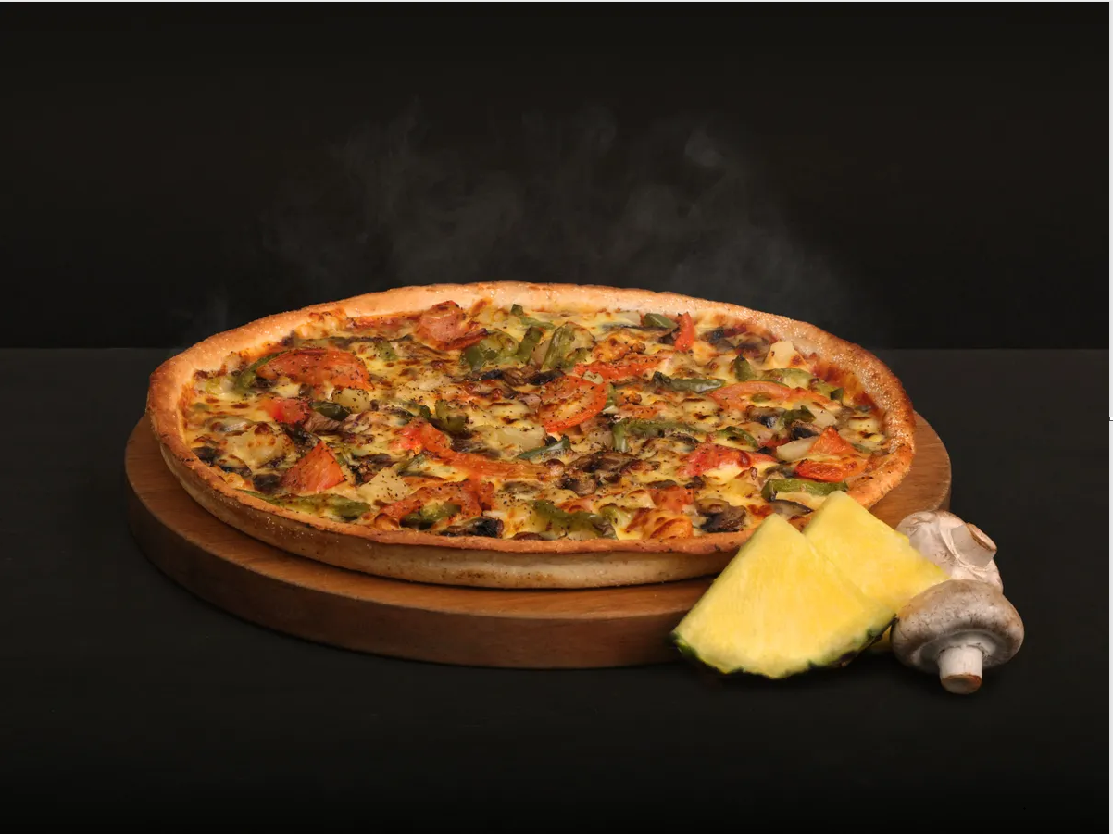Pride

Mushrooms, Capsicum, Tomatoes, Pineapple and Onions. Optional: Kalamata Olives, Garlic, Jalapeno Peppers.

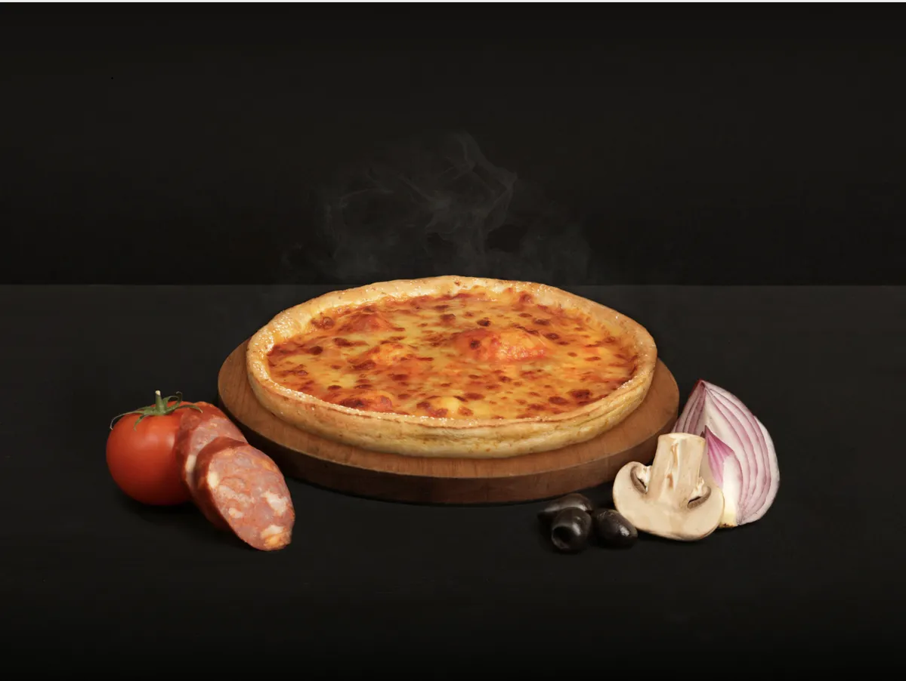333 - Hellthy Kids Pizza

Tomato Base Sauce, 100% Mozzarella Cheese and 1 Topping.

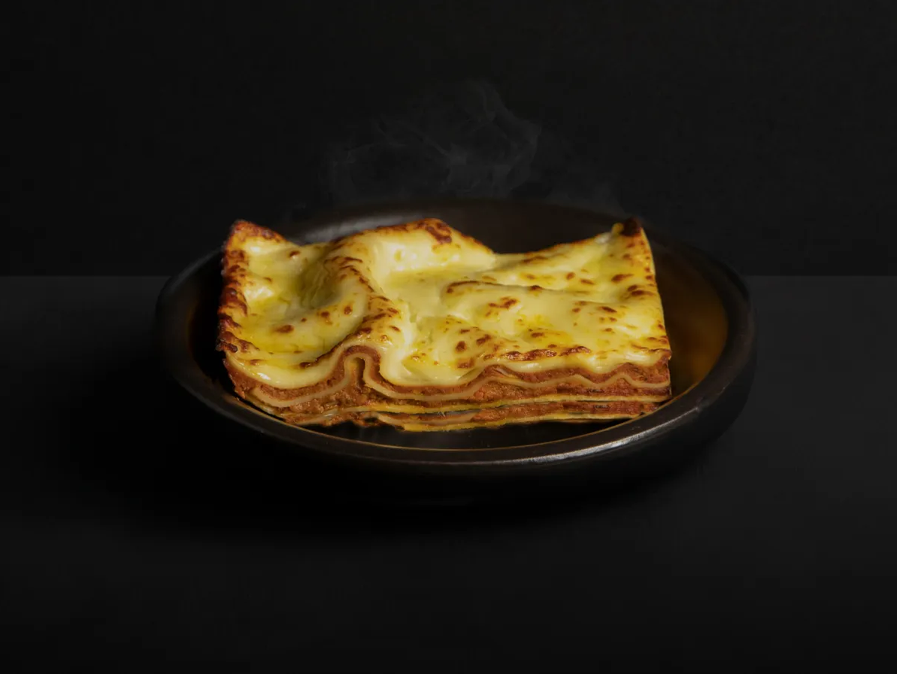Lasagne

Lasagne layered with a rich Beef and Pork Bolognese with mushrooms and Béchamel Sauce.

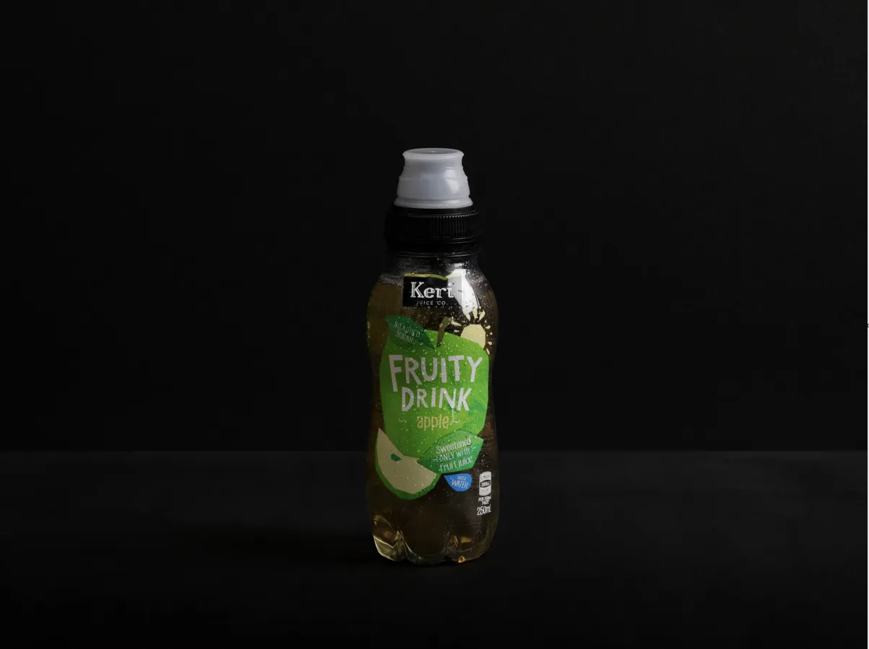

Kids Keri Apple

Available in 250ml

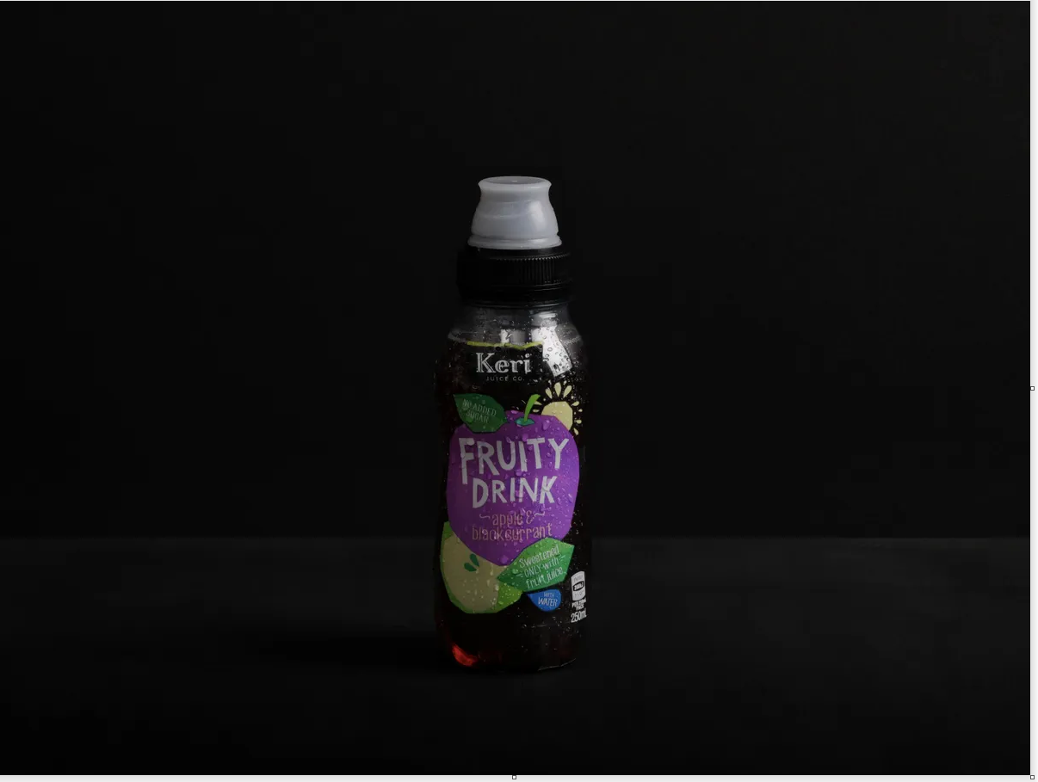

Kids Keri Apple & Blackcurrant

Available in 250ml

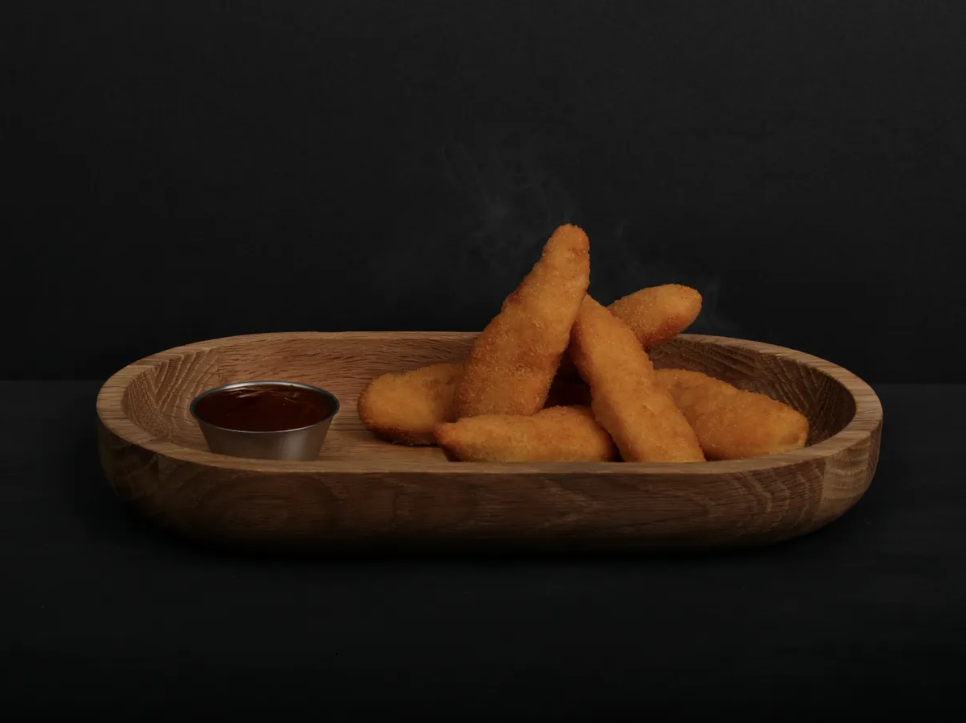

Free Range Chicken Tenders

6 Crumbed and deep fried Chicken Tenders, served with your choice of dip

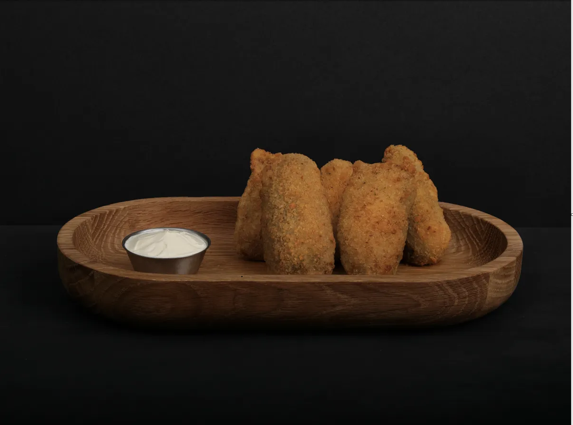

Jalapeno Poppers

5 Jalapeño poppers, hand-filled with our secret 3-cheese mix, double crumbed and deep fried, served with your choice of dip.

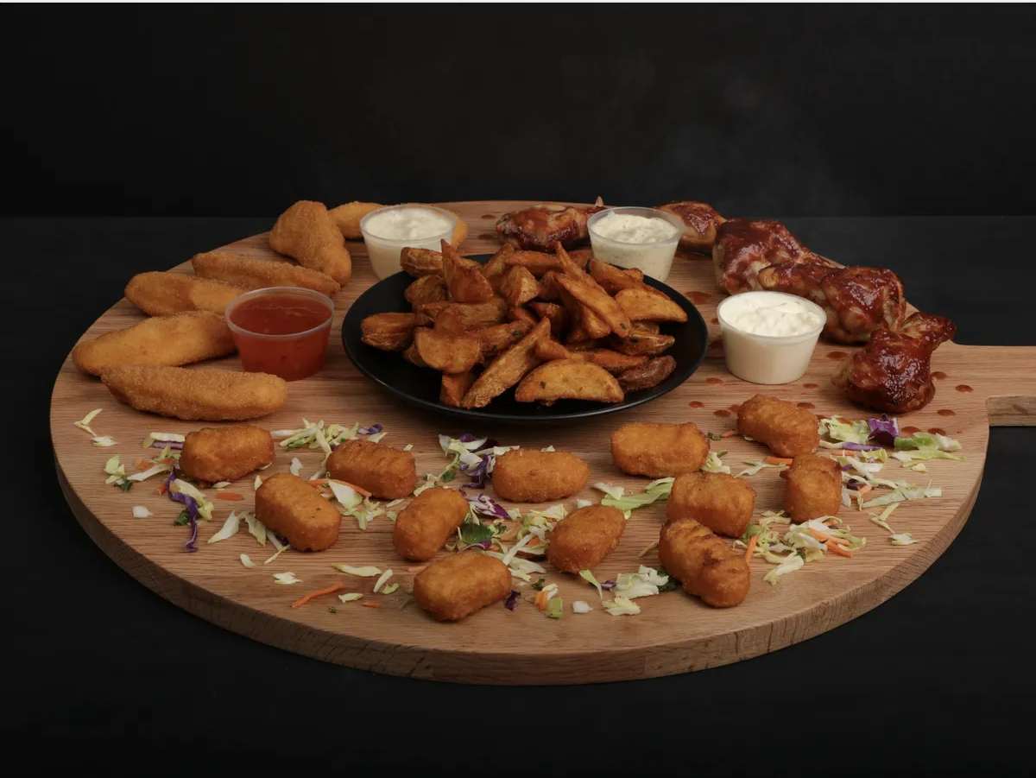

Splatter Fest Platter Part 1

Free Range Chicken Tenders, Corn Nuggets, Cajun Wedges, Free Range Chicken Wings lashed with Cola BBQ Sauce & a selection of sauces.

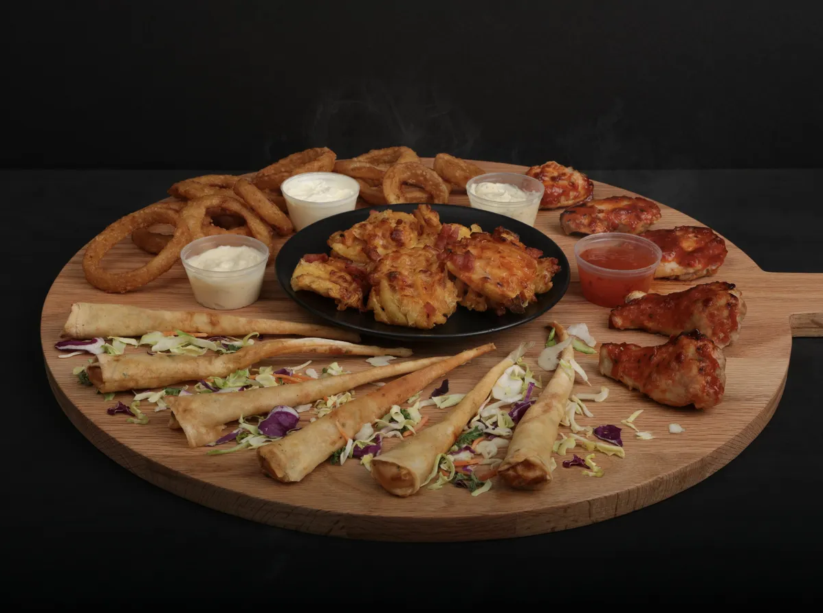

Splatter Fest Platter Part 2

Holy Loaded Fries, Beer-battered Onion Rings, Prawn Horns, Free Range Chicken Wings lashed with Spicy APA Sauce & a selection of sauces.

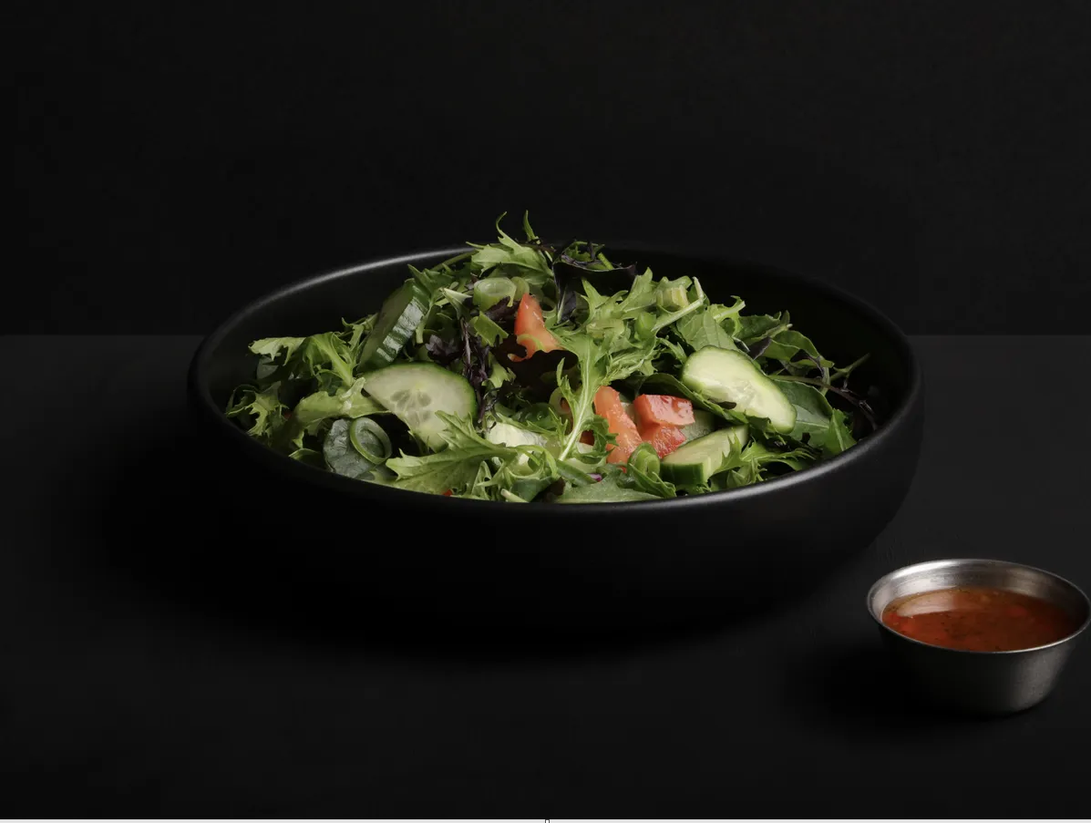

Fresh Green Salad

All the Essentials - Lettuce, Tomato, Cucumber and Spring Onion with your choice of dressing on the side.

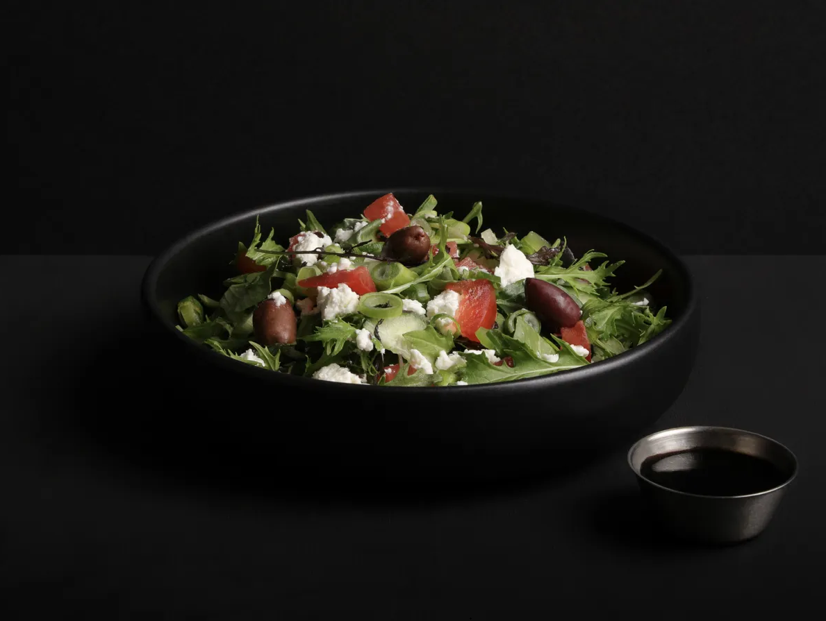

Greek Salad

Your choice of Lettuce or Slaw with Spring onions, Cucumber, Tomatoes, Kalamata Olives & Feta - with your choice of dressing on the side.

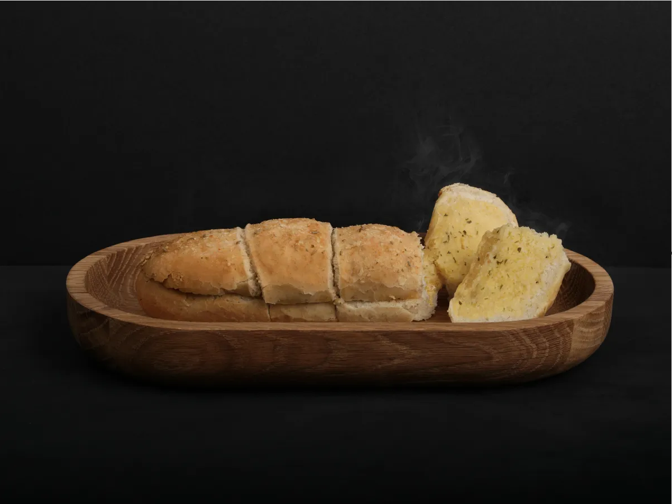

Garlic Bread

Crusty herb loaf doused with garlic butter

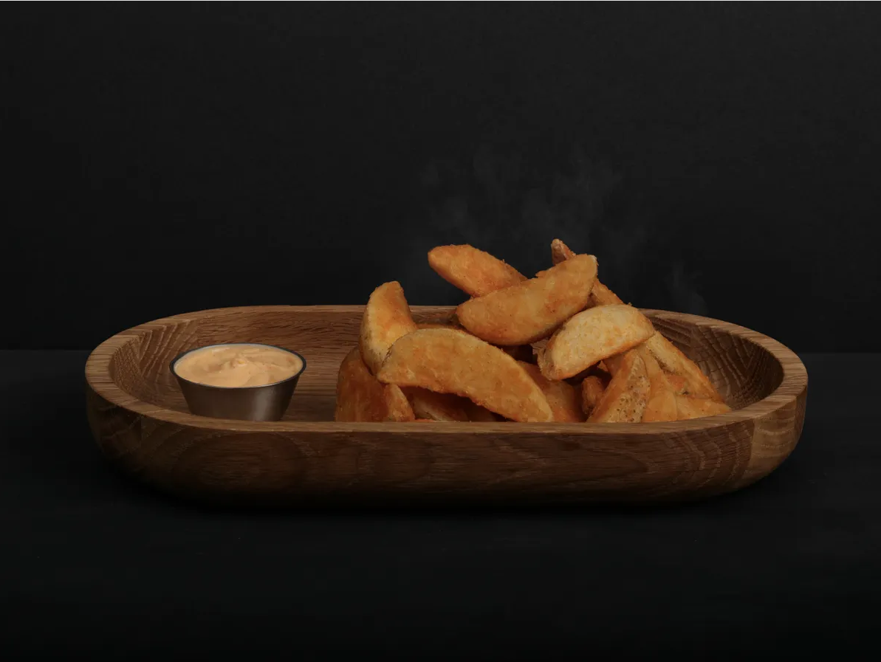

Plain Wedges

Deep fried beer battered potato wedges served with a dip of your choice.

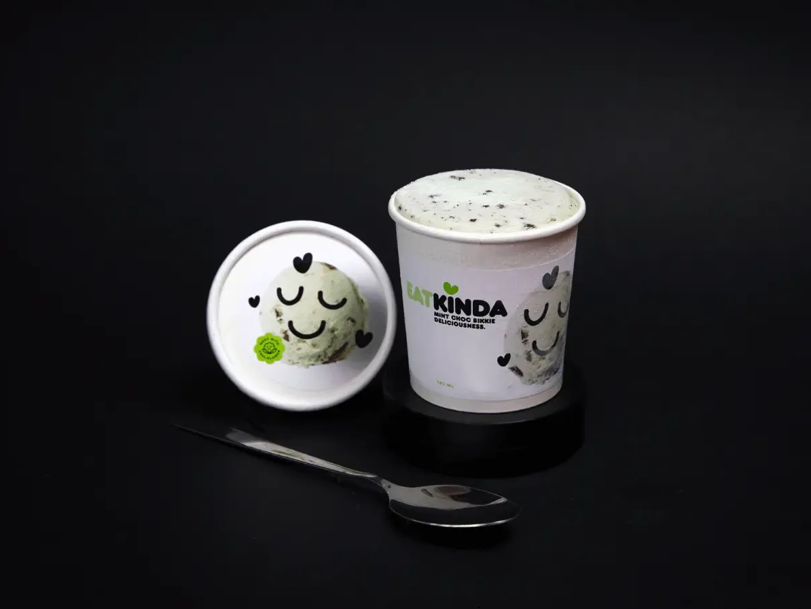

Mint Choc Bikkie

Silky mint ice cream with crumbly chunks of gluten-free chocolate biscuits. 140ml (2 serves). Plant-based.

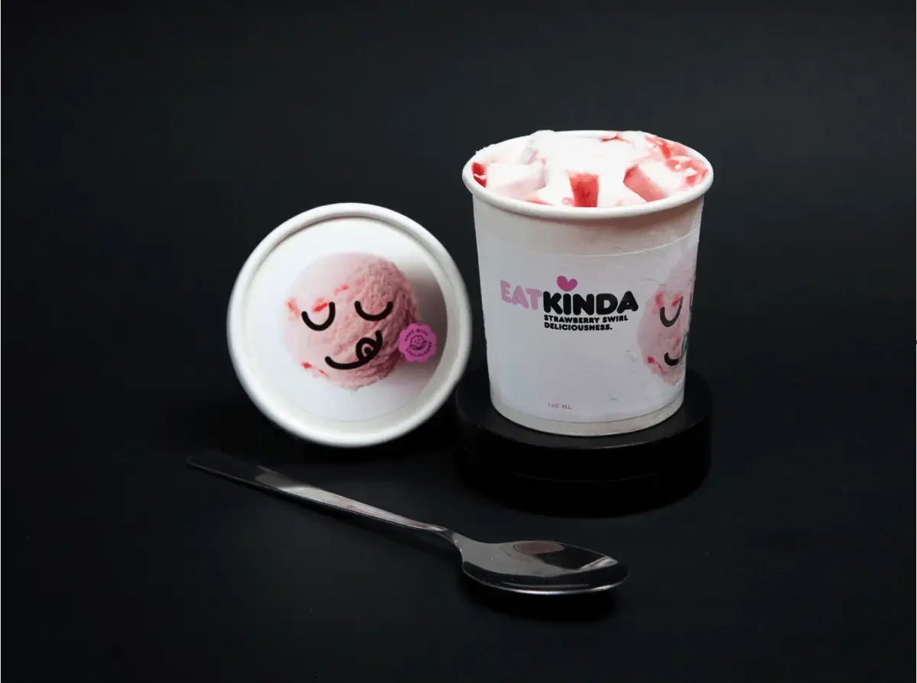

Strawberry Swirl

It's like sinking your fangs into a fluffy pink cloud bursting with summer's best berries. 140ml (2 serves). Plant-based.

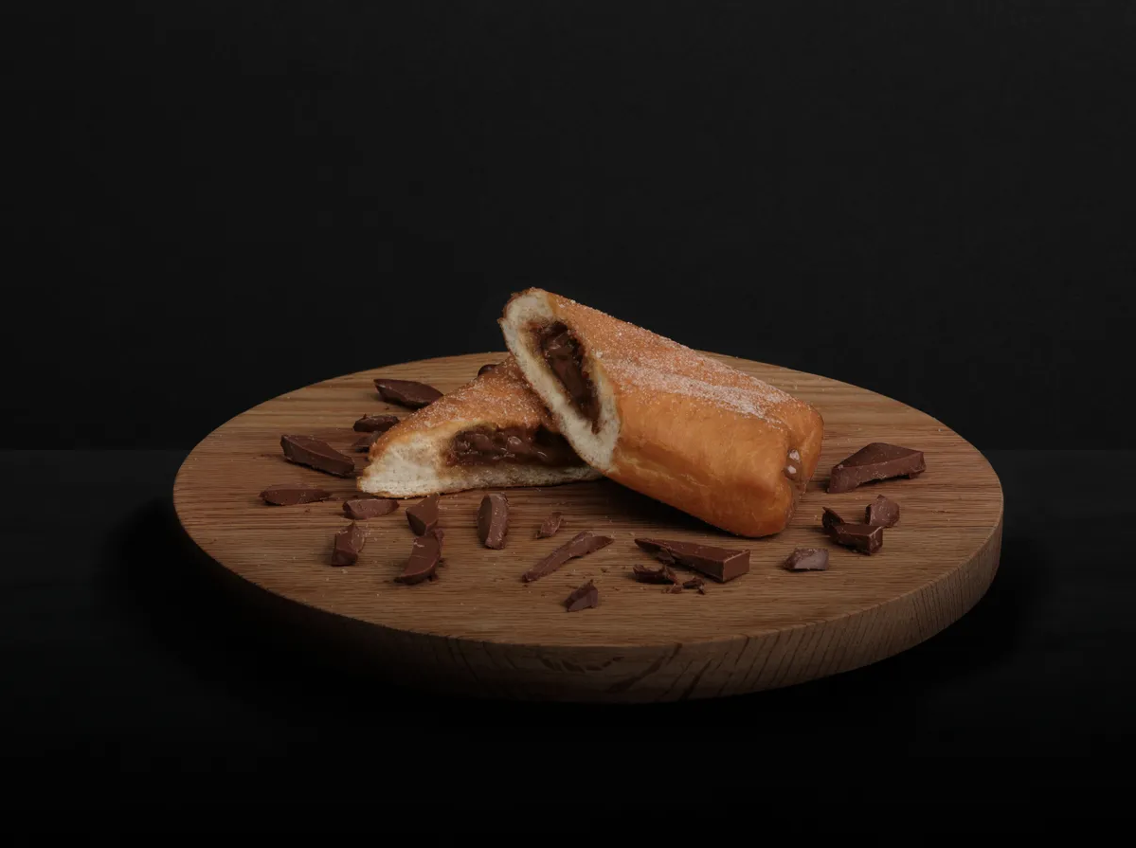Unholy Donut

A warm Donut, freshly fried and sinfully pumped full of decadent Salted Caramel plus your choice of Dark, Milk or White Chocolate.

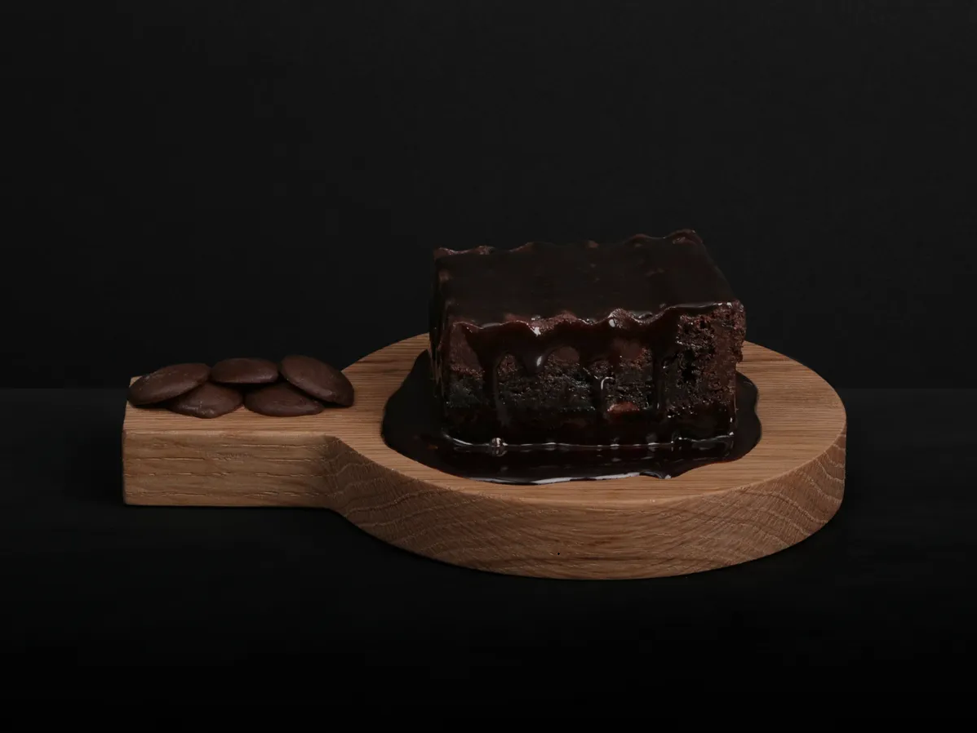

Hot Brownie

Hot Gluten Free Chocolate Brownie, drenched in a luxurious chocolate ganache (GF)

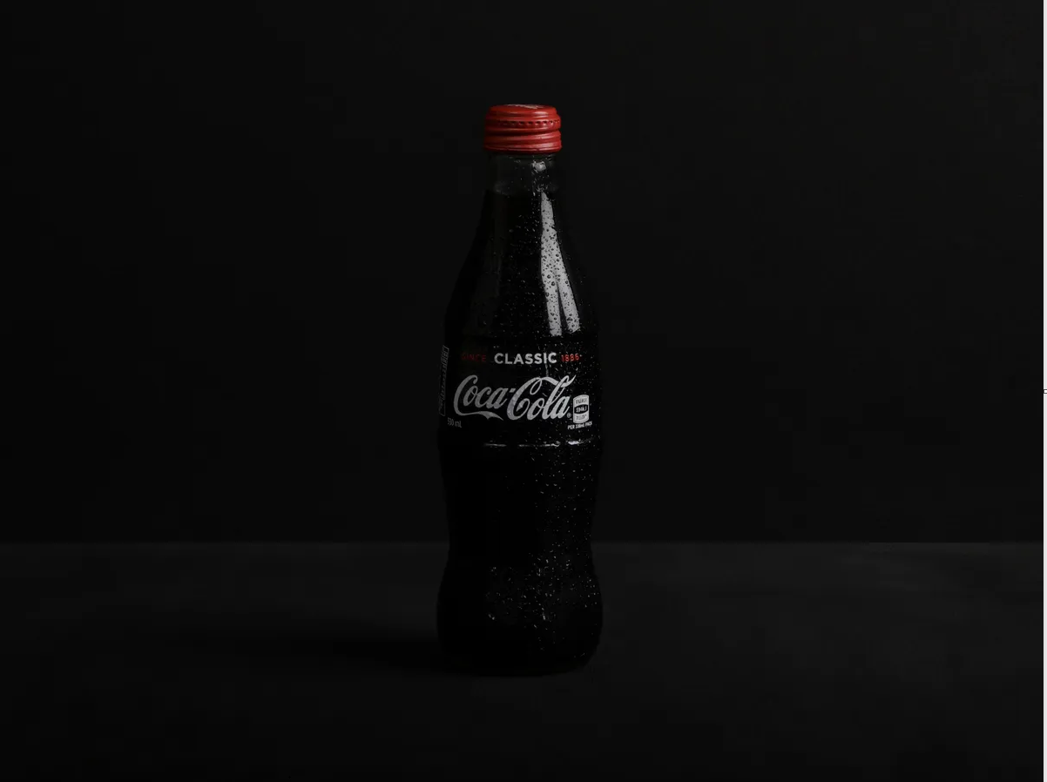Coke

Available in 1.5L and 330ml

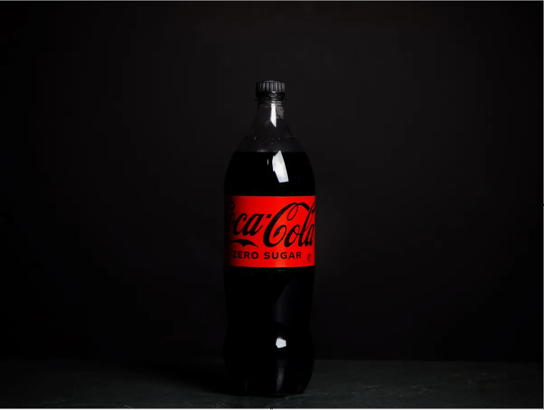

Coke Zero Sugar

Available in 300ml and 1.5L

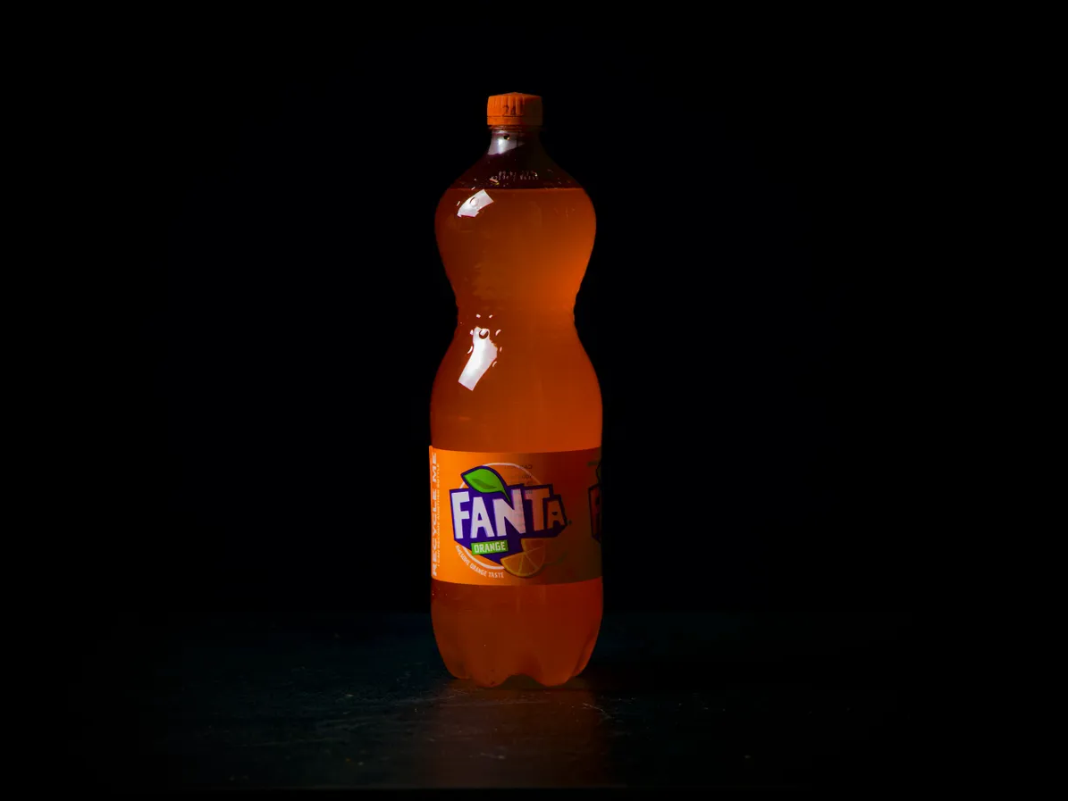Fanta

Available in 1.5L

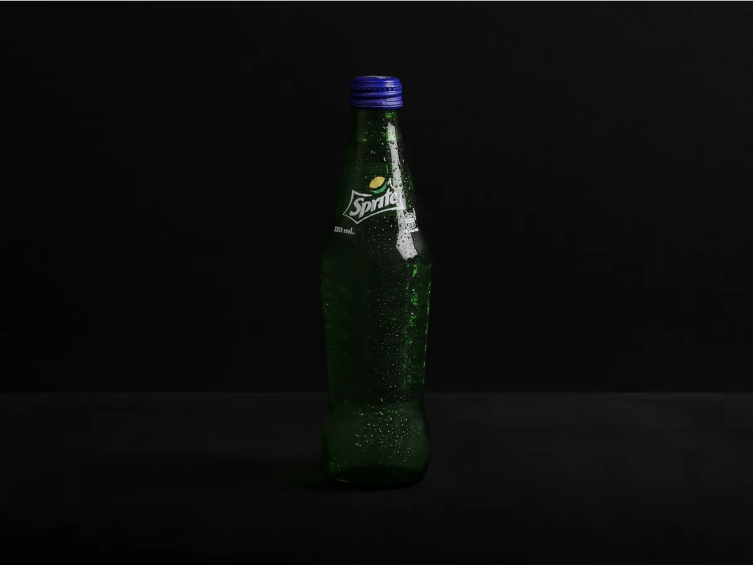

Sprite

Available in 1.5L and 330ml

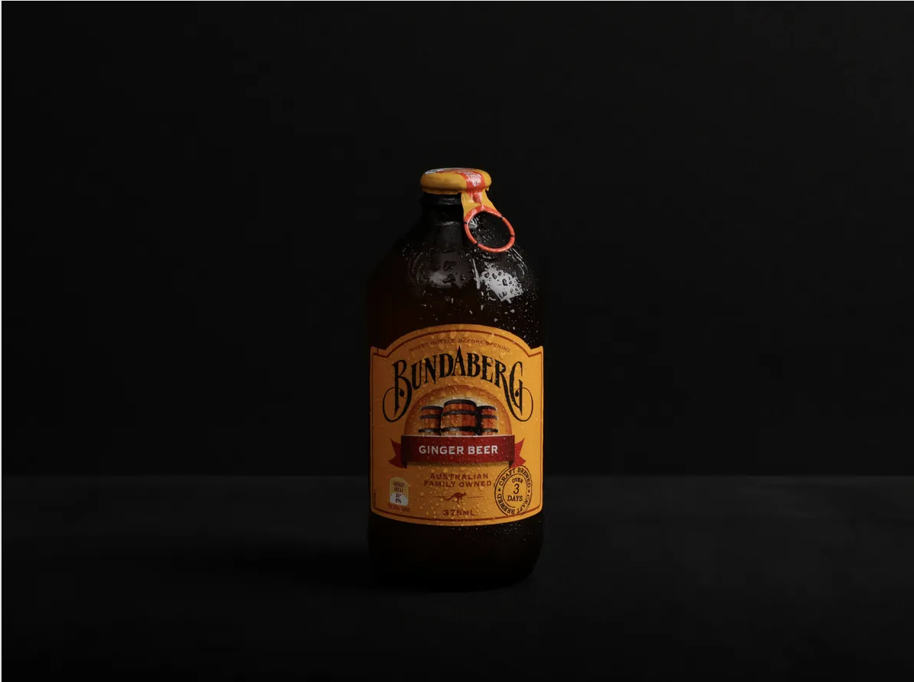

Bundaberg

Available in 750ml and 375ml

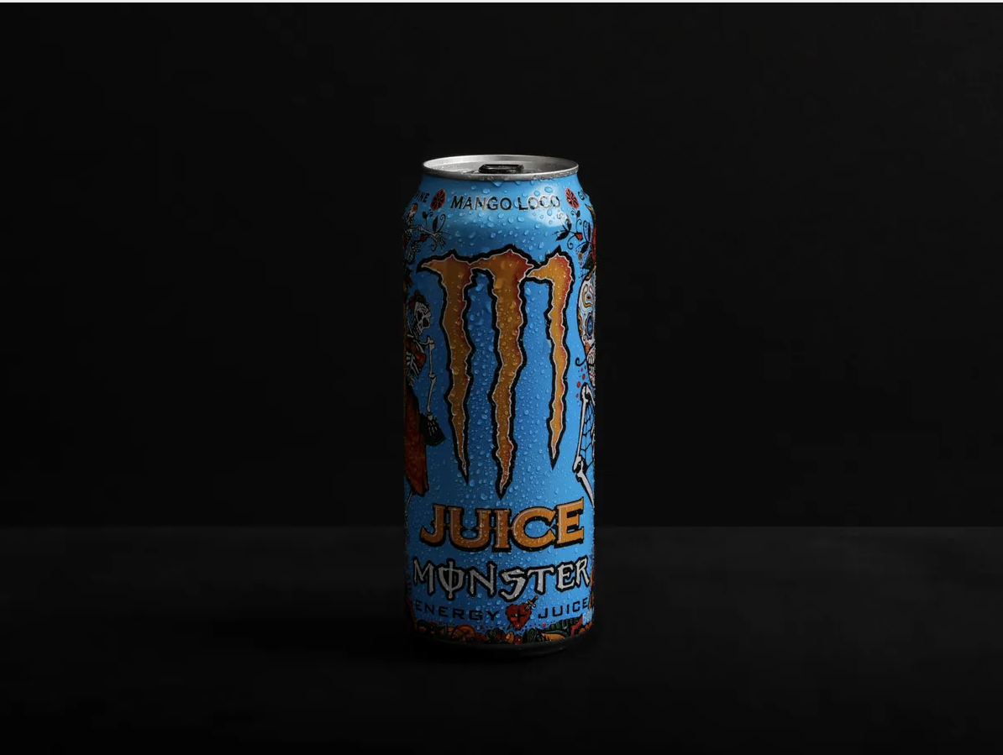Monster Energy Mango Loco

Available in 500ml

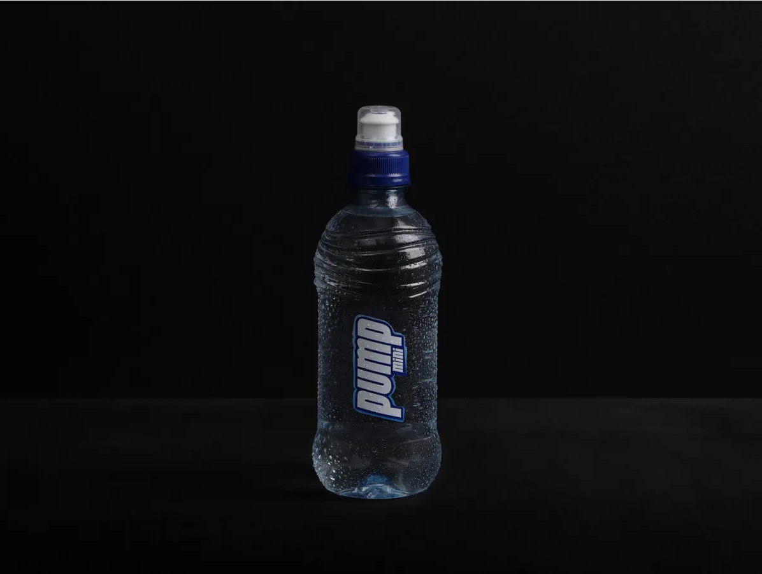

Pump

Available in 750ml and 400ml